Look if the row exists, if exists then update, if not insert

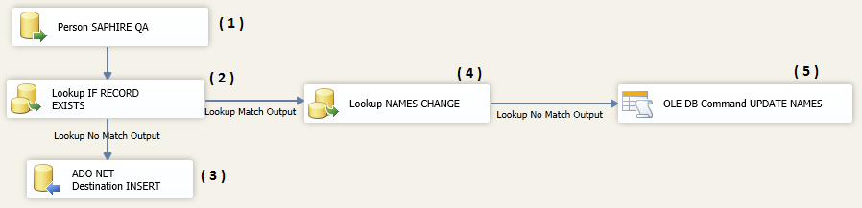

1. Read data
2. Look up key, check if the information exists
3. If it doesn’t exist then INSERT
4. Look up to check if data has changed (FirstName and LastName)
5. If data has changed then update

* The connection string in (1) is the data to evaluate
* **The connection string in (2), (3), (4) and (5), the destination**, where we want to check / update / insert data
* In the Lookup, we will compare (1) against the data in the destination

CONNECTIONS

1. **From SOURCE**
2. **DESTINY WITH PROVIDER**
3. **DESTINY**
4. **DESTINY WITH PROVIDER**
5. **DESTINY WITH PROVIDER**

**DESTINY**

Data Source=DALSAPENTDBT01;Initial Catalog=SAPhIREDev_2_0;Persist Security Info=True;Integrated Security=SSPI;

**DESTINY WITH PROVIDER**

Data Source=DALSAPENTDBT01;Initial Catalog=SAPhIREDev_2_0;Persist Security Info=True;Integrated Security=SSPI; Provider=SQLNCLI11.1"

**Setting Lookup ( 2 )**

|  |  |
| --- | --- |
| **Set General** | **Set connection** |
|  |  |

Now set columns to loop up and to update

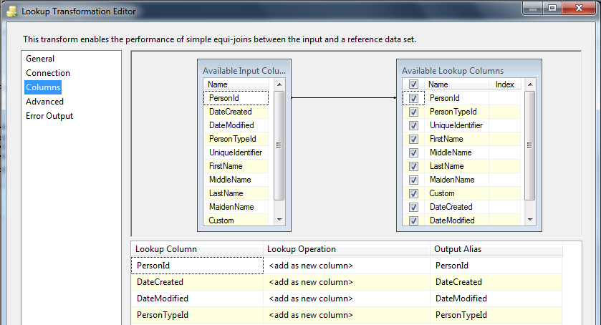

**Set Insert in Destination ( 3 )**

|  |  |
| --- | --- |
| **Connection** | **Mapping** |
|  |  |

**Lookup to check if the Names have changed ( 4 )**

|  |  |
| --- | --- |
| **Set General** | **Set connection** |
|  |  |

Now set columns to loop up and to update

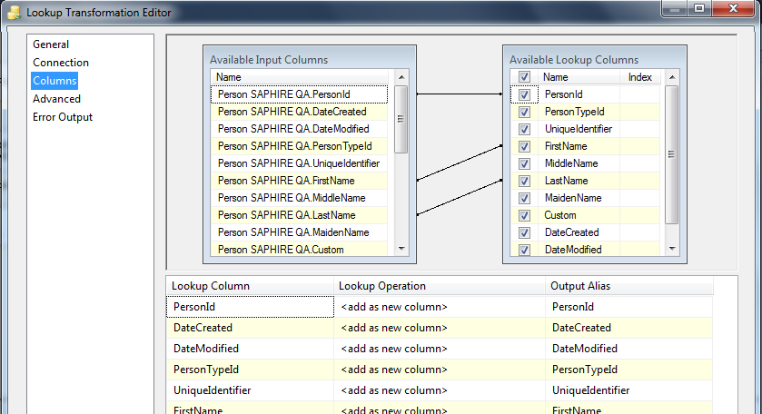

**Update information when Key exists ( 5 )**

Set connection

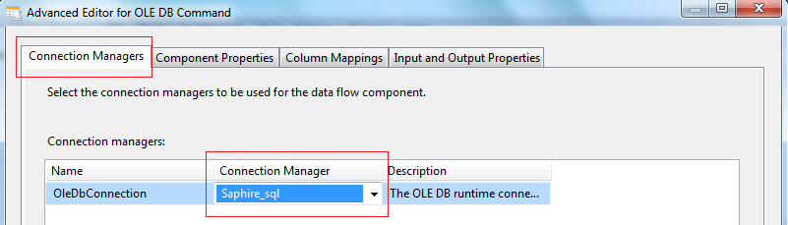

**Configure SQL sentence**

UPDATE PERSON

SET firstName = ?,

middleName = ?,

lastName = ?

WHERE personID = ?

AND firstName <> ?

**OR CALL A STORE PROCEDURE EXEC SP_UPDATE ?, ?, ?**

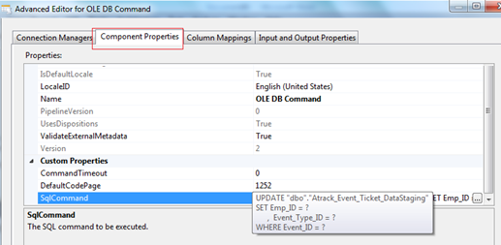

**Map the columns to the parameters (Param_0 is the first ‘?’ in the query)**

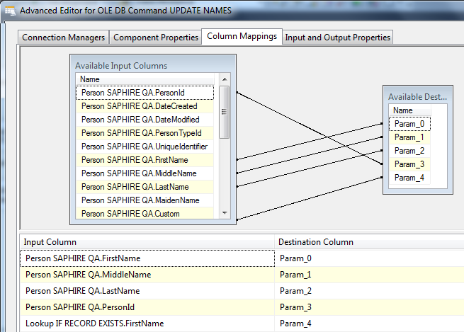

In the mapping you have the source coming (Available Input Columns)

**Set type of parameters, int, string, date**

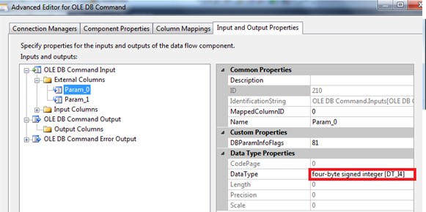

Another option is retriving the data and make a sequence that will call a procedure UPDATE

"dbo"."Atrack_Event_Ticket_DataStaging"

SET Emp_ID = @Emp_ID,

Event_Type_ID = @Event_Type_ID

WHERE Event_ID = @Event_ID

If not updated, then Insert

IF (@ROWCOUNT = 0)

BEGIN

INSERT INTO Atrack_Event_Ticket_DataStaging …..

END